*Lab 5: Operational Amplifiers I*

Physics 411

John Waczak

11/27/2016

Lab Partner: Kyle Tafoya

Introduction

Lab 5 examined the integrated circuit called the operational amplifier (hereafter referred to as an op-amp). This chip is comprised of many of the passive components that we have previously studied – the resistor, capacitor, transistor, etc… Figure one below shows an example circuit diagram for one op-amp.

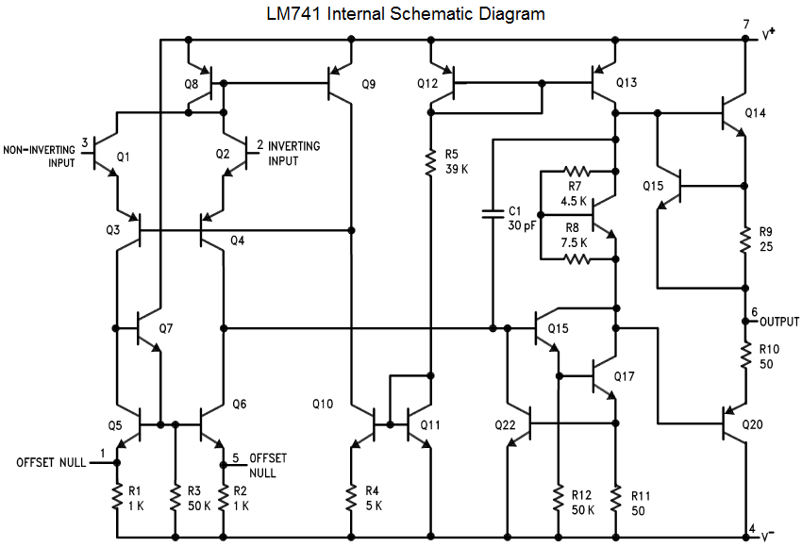

Figure 1: The internals of the op-amp

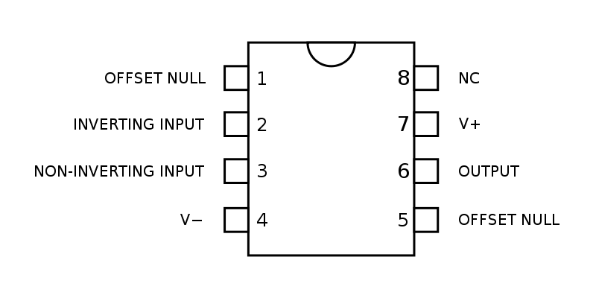 Clearly this circuit is quite complicated. Fortunately for our purposes, the chip can be simplified into a single ‘component’ that has 8 leads. Connecting power, input signal, and an output load to various pins can result in widely different results which are what makes the op-amp so versatile. Figure 2 to the right shows the pinout diagram for most 8 pin op-amps.

Some of the various uses of the op-amp include: amplifier, inverting-amplifier, summing/difference amplifier, differentiator, integrator, and a signal filter. Lab 5 examined many of these uses for op-amps as well as some important physical traits such as the gain. The following lab report details the results of 5 experiments that analyzed the behavior of various uses of the op amp.

Figure 2: Op-amp pinout

In order to theoretically analyze the op-amp, two ‘Golden Rules’ were applied to model the integrated circuit’s behavior. They are as follows:

1. *The output does whatever it must to keep the voltage difference between the two inputs zero.*
2. *The inputs draw no current.*

Procedure

1. 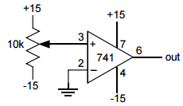**Open loop gain**

Figure 3: Open loop gain circuit

The first experiment performed looked at the gain on the output pin (6) of the LM741 op-amp. Figure 3 to the right shows the circuit used with markings corresponding to the number of the pins on the diagram from Figure 2.

Op amps require some kind of power in addition to an input signal. For all experiments performed in this lab, this was given as + 15 and -15 volts to pins 7 and 4. For subsequent diagrams, this will be assumed and not included. To measure the gain, a 10 kΩ potentiometer was placed between the +/- 15 V rails and connected to the positive input pin (non-inverting input on figure 2). The negative pin was connected to ground and the output was measured from pin 6 using the oscilloscope. The lab asked us to try and adjust the potentiometer so that the output is zero. Finally, we were asked to compare this experience with the reported gain for the LM741. The listed typical gain for the LM741 was 200 V/mV = 200,000 V/V.

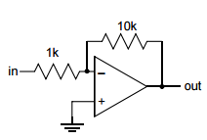Because there is no feedback used from the output signal, the ‘Golden Rules’ of op amps do not help analyze the Open Loop circuit.

1. **Inverting Amplifier**

The second experiment analyzed the circuit shown to the right in figure 4. Rather than using a 10 kΩ potentiometer, a simple 1 kΩ resistor was placed in series with the inverting input pin (2). Likewise, the non-inverting pin was tied to ground. The only other major addition was that a feedback loop was created by using a 10 kΩ resistor to tie the input and output pins.

Figure 4: Inverting amplifier circuit

Using the golden rules we can deduce that:

* V(-) = V(+) = 0 V

$I_{-}=I_{+}=0 A$

$I_{1k}=I_{10k}$

$\frac{V_{in}-0}{R_{1k}}=\frac{0-V_{out}}{R_{10k}}$

$\frac{V_{out}}{V_{in}}=-\frac{R_{10k}}{R_{1k}}$

Thus, the theoretical gain for the inverting amplifier shown in figure 4 is 10k/10 = 10. To test the circuit, a low frequency (5kHz) sinewave was created using a function generator. As there was no ‘fuzz’ on the output we chose not to employ any 0.1µF bypass capacitors. The circuit gain was then tested for a variety of frequencies from 1Hz to 5MHz. After, the circuit gain was increased by a factor of 10 and then 100, repeating the same gain measurements for the same frequencies.

1. **Non-Inverting Amplifier**

For the third experiment, the circuit shown in figure 5 was built. A low frequency sinewave input (1kHz) was sent to the input pin by the function generator and the output voltage was measured using the oscilloscope.

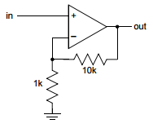

Using the golden rules, we can once more deduce that:



$V_{-}=V_{+}$

Figure 5: Non-inverting Amplifier

$V_{out}-IR_{10k}-IR_{1k}=0$

$I= V_{out}\left(\frac{1}{R_{10k}+R_{1k}}\right)$

$V_{-}-0= V_{out}\left(\frac{R_{10k}}{R_{10k}+R_{1k}}\right)$

$V_{in}= V_{out}\left(\frac{R_{10k}}{R_{10k}+R_{1k}}\right)$

$\frac{V_{out}}{V_{in}}=\left(\frac{R_{10k}}{R_{10k}+R_{1k}}\right)=1+\frac{R_{10k}}{R_{1k}}$

Thus the goal of experiment 3 was to see if the measured gain matched that of our theoretical calculation.

1. **Follower**

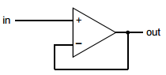

The fourth experiment had us build the circuit shown in Figure 6 dubbed the ‘follower’ circuit. As the diagram shows, the input signal is connected to the positive pin and output is connected back to the negative pin providing ‘negative feedback’ for the circuit.

Figure 6: Follower circuit

Let’s apply the golden rules in order to make a prediction for how this circuit should behave:

$V_{+}=V_{-}$

$V_{-}=V_{out}$

$V_{+}=V_{in}$

$V_{in}=V_{out}$

So we should expect to see that there is no gain on the output signal. To test this theory, an input sinewave at 1kHz was passed to the input pin and the output was measured using an oscilloscope.

1. 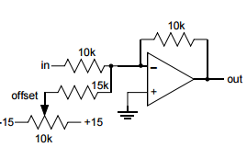**Summing Amplifier**

For the final experiment, the summing amplifier circuit shown if figure 7 was built. For this circuit, the negative input was used while the positive was tied to ground. Negative feedback is provided to the negative input pin by jumping to the output via a 10 kΩ resistor. An input sinewave at 1kHz was provided to the negative input pin through another 10kΩ resistor. In parallel to the input, a 15 kΩ resistor was connected to a 10 kΩ potentiometer tied between +/- 15 volts. By tuning the potentiometer, the ‘additional voltage’ supplied to the input pin was regulated.

Figure 7: Summing Amplifier Circuit

Finally, the golden rules can be applied once more to develop some theory regarding the behavior of the summing amplifier.

$V_{+}=V_{-}$

$I_{10k}+I_{pot}=I_{feedback}$

$\frac{V_{in}}{R_{10k}}+\frac{V_{offset}}{R_{15k}}=-\frac{V_{out}}{R_{10k}}$

$V_{out}=-R_{10k}\left(\frac{V_{in}}{R_{10k}}+\frac{V_{offset}}{R_{15k}}\right)$

So we should expect that the output is essentially the regular gain for the inverting amplifier except there is a slight ‘addition’ from the offset voltage supplied by the potentiometer. Measurements were taken for the output and input voltages in order to determine the empirical gain and to test whether or not it matched the theoretical prediction outlined above.

Results

1. **Open loop gain**

We built the open-loop circuit shown in figure 3 and tried to tweak the potentiometer using a screwdriver to make the output voltage zero. No matter what, the op-amp always output + or -15 volts. As previously mentioned, the reported gain for the op-amp is listed as 200,000 V/V typically so it is no wonder that we could not make the output be zero as that would require that less than 0.002 mV be produced using the potentiometer. The reason why the output could not reach magnitudes of the thousands or hundreds of thousands of volts is simply because the op-amp is supplied with +/- 15 V dc and so cannot physically exceed this limit by conservation of energy.

1. **Inverting Amplifier**

For the second experiment, the inverting amplifier was built according to figure 4 shown previously. By the golden rule equation we developed, the theoretical gain is:

$-\frac{R_{10k}}{R_{1k}}=-\frac{10.8 k}{1k}= -10$.8 As per the instructions, an input sinewave was introduced and the input and output voltages were recorded for a range of frequencies. Graph one below shows magnitude of the measured gain (non-negative as we measured using the scope).

Graph 1: Inverting Amplifier Gain

As the graph clearly shows, the gain for was almost exactly 10.8 as expected until the 100 kHz mark. After this point, it appears that the internals of the op-amp can’t keep up with the frequency of the input and so the gain begins to decrease sharply.

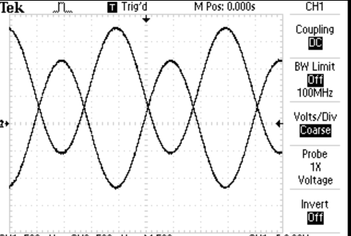For the two subsequent increases in gain (x 98.7 and x990), we find that the behavior is similar. For frequencies below 100 kHz, the gain was such that the output was the maximum 15 volts (higher voltages could not be reached for reasons previously mentioned). Again after, 100 kHz, the gain sharply dropped off towards zero. These measurements were made using the oscilloscope cursor to measure the peaks of the input and output signals. Because of this, the gains shown in graph one are positive as two adjacent peaks were measured as opposed to the chronologically correct negative output in order to help facilitate taking the data. Graph 2 to the right shows an example of the oscilloscope output for the inverting amplifier. The output is both amplified and shifted by pi/4.

Graph 2: Oscilloscope output - inverting amplifier

1. **Non-inverting Amplifier**

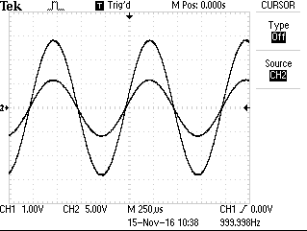For the third experiment, the non-inverting amplifier was created as shown in figure 5. The theoretical gain was shown to be 11.8. In order to be able to see this gain, the amplitude of the input sinewave had to be turned all the way to 2.3 Vpp. This corresponded to the values Vout = 14.0 V and Vin = 1.15 resulting in an experimental gain of 12.17. This value is very close to the theoretical, likely differing due to error in the value of the resistors. Graph 3 above shows the oscilloscope output for and input for the non-inverting amplifier. The output is amplified and in phase with the input.

Graph 3: Oscilloscope output for non-inverting amplifier

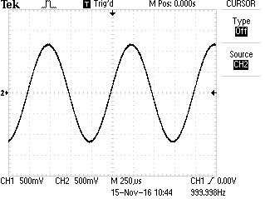

Graph 4: Oscilloscope output for the follower circuit

1. **Follower**

The fourth experiment involved building the follower circuit shown in figure 6. As expected by the golden rules (outlined in the previous section) there was no output gain for a low frequency input sinewave.

One might think that the graph only shows the output or input signal however as there is no gain, the two are superimposed upon each other as evidenced by the V/div setting being present for both channels.

1. **Summing Amplifier**

For the final experiment of lab 5, the summing amplifier circuit was built according to figure 7. The input was driven with a low frequency. From the golden rules, we expected that the output signal would experience a gain equal to that of the inverting amplifier plus an additional ‘offset’ supplied by the potentiometer – hence the name summing amplifier. Our findings agreed with the theory. Because the ‘inverting amplifier’ section of the circuit consisted of two 10 kΩ resistors, the gain was from the input was zero. The range of offsets we could produce was roughly 0 Volts (when the potentiometer was floating in the middle) and +/- 0.1 Volts. This was controlled by turning the knob on the potentiometer with a screwdriver. These results do agree with the application of the golden rules. The gain due to the input signal was zero and the offset could be controlled by increasing the additional voltage applied by the potentiometer.

Conclusion

This lab demonstrated a few of the uses for the integrated circuit called the operational amplifier. The first experiment analyzed the open loop gain, demonstrating that the operational amplifier does in fact amplify the input signal. The second experiment showed one of the many uses for the op-amp dubbed the inverting amplifier. In addition to amplifying the input signal, this circuit inverts the input thereby switching the sign of the output. The third experiment tested the non-inverting amplifier circuit which like the first experiment, can be used to control the gain on the output pin. The fourth experiment demonstrated that simply providing feedback creates a follower circuit such that the output voltage is the same as the input. Finally, the last experiment showed how the summing amplifier can be used to introduce specific offsets to the output signal. Altogether, these various circuits introduce the many uses for the operational amplifier and serve as an introduction to the world of integrated circuits.

Works cited

1. <http://www.ti.com/ww/en/bobpease/assets/AN-31.pdf>
2. <http://www.ti.com/lit/ds/symlink/lm741.pdf>